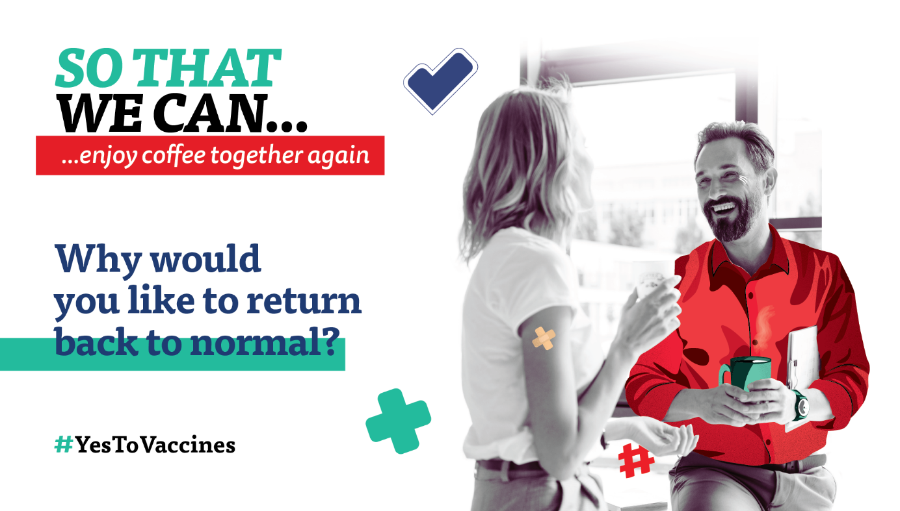

Dear colleagues,

In the recent months, many of you have approached us with questions about recommendations or restrictions regarding the pandemic. We know that just as you have been responsibly trying to understand the government measures and guidelines since last March, many of you are now trying to educate yourself and make the right decision about vaccination.

We care about the health of you and your loved ones. As we are monitoring various verified resources, we want to share with you useful information, so that you can make the right decision for you and your life. Therefore, in cooperation with scientists, we are bringing you facts that will help you orient yourself in the topic. Of course, each body and medical condition is unique, so in case of specific questions or guidelines, consult whether the vaccine is appropriate for you with your doctor.

Our goal is not to force anyone to get vaccinated. We simply want to be a useful source of information for you so that you can make free and responsible decisions based on facts. And while you may still have time to get vaccinated due to your age or medical condition, you can still become a trusted adviser for those who are eligible for vaccinations before you.

For more information, visit our intranet / Yammer / see the brochure attached or click on www.zaockujemsa.sk .... (delete or edit as appropriate)

Signature